CISA Email to High School Students

Hello Student Leader!
You have been recommended to attend the FREE VIRTUAL Careers in Student Affairs Institute presented by the University of Colorado Colorado Springs on Saturday, October 17th, 2020 from 9am-1pm!
If you are currently involved in your school and enjoy participating in clubs and organizations such as student council, student clubs, and Link Crew, Student Affairs may be a great career pathway for you! Student Affairs is a career that allows you to help students be successful in college while working on a college campus. Careers opportunities after college include work in areas of colleges like residence life, academic advising, financial aid, student activities, and new student orientation.
During the virtual Careers in Student Affairs Institute, you will learn how to help college students be success all while you are learning to be a successful college student yourself! One of the best things about working as a Student Affairs professional on a college campus is the fact that it opens doors for you all over the country working with student leaders!
The Institute will include sessions for high school students focusing on:
-Helping Skills and Leadership Development
-Exploring Careers in Student Affairs
-Making the Most of the College Experience
For more information, please visit https://www.uccs.edu/coe/departments/leadership-research-and-foundations/programs/sahe/CSA-virtual-conference
Registration for this event will be open from August 24-October 9, 2020. Please reach out to Karen Perez, University of Colorado Colorado Springs College of Education Graduate Assistant (st-coe09@uccs.edu), if you have any questions.
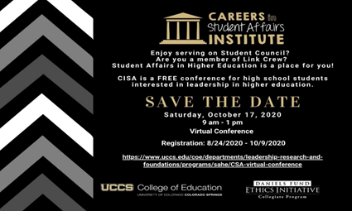
Thank you!

